Planning Beyond Predictability
“LayScen” — Layered Adaptive Scenario Planning
An Integrated Framework for Urban Resilience
Ranu Aggarwal, AICP
September 2026

Suggested citation: Aggarwal, R. (2026). Planning Beyond Predictability: “LayScen” — Layered Adaptive Scenario Planning, An Integrated Framework for Urban Resilience. White paper. GitHub. https://github.com/…
Distributed under CC BY 4.0

Contents
Scope and Intent of This Paper 3
Abstract 3
Executive Summary 4
The Challenge 4
What is LayScen? 4
Who It Is For 4
What Practitioners Can Expect to Gain 4
The Framework and Workflow at a Glance 5
How This Document Is Organized 5
Invitation 5
Limits of Current Planning Practice 6
Conventional Planning 6
Adaptive Planning 7
Key Insight 8
“LayScen” (Layered Adaptive Scenario Planning) - an Integrated Framework for Urban Resilience. 8
Conceptual Foundations 9
What Distinguishes LayScen 11
Workflow and Methodology 12
Phase 1: Systems Scan and Driver Selection 14
Phase 2: Morphological Analysis — Structuring Uncertainty 14
Phase 3: Cross-Impact Analysis — Testing Consistency 14
Phase 4: Scenario Development — Building Scenarios 14
Phase 5: Solutions Design — Crafting Responses (Policies and Strategies) 15
Phase 6: Robust Decisions — Structuring Cross-Scenario Synthesis 15
Phase 7: Monitoring, Learning, and Adaptation 15
Phase 8: Institutionalization and Governance 16
Illustrative Operational Walkthrough 16
Phase 1 — Systems Scan and Driver Selection 16
Phase 2 — Morphological Analysis 17
Phase 3 — Cross-Impact Analysis 18
Phase 4 — Scenario Development 19
Phase 5 — Solutions Design 20
Phase 6 — Robust Decisions 21
Phase 7 — Monitoring, Learning, and Adaptation 21
Phase 8 — Institutionalization and Governance 21
Systemwide Approach 22
Implementation Considerations and Workflow Support 22
Potential Applications 23
Limitations 23
Future Development and Research 23
Conclusion 23
Acknowledgement 24
References and Supporting Literature 24

Scope and Intent of This Paper
This white paper documents the LayScen framework as formulated by the author as of April 2026. It includes the framework’s conceptual foundations, workflow architecture, operational logic, and an illustrative implementation walkthrough. The framework and workflow presented here are largely complete and are offered for exploration and evaluation for real world implementation. A portable application to operationalize the workflow is under development and will soon follow for testing and refinement in real world planning contexts, shaped by user input and feedback from pilot applications.
This document is a framework formulation and operational synthesis, not empirical research, a validated methodology, or a finished software product specification. This document is intended to stand as a definitive statement of the framework. Continued refinement of workflow structure, terminology, implementation mechanisms, and evaluation approaches will be carried forward through professional dialogue, pilot application, user feedback, and the portable application itself.
Readers are invited to engage now and to help shape what follows.

Abstract
Urban planning increasingly operates under compounding uncertainty shaped by factors such as climate volatility, housing pressures, infrastructure stress, economic instability, and disruptive technological change and their interaction across urban systems. Conventional plans assume relative stable conditions and struggle to keep pace with these dynamics. Even adaptive plans often remain fragmented across domains — each built around its own drivers (the forces it plans around), its own triggers (the signals that prompt change), and its own monitoring metrics and adaptation pathways, operating on parallel tracks rather than in coordination.
This paper proposes LayScen (Layered Adaptive Scenario Planning), a practitioner-oriented framework that integrates the concepts of layering/layered systems thinking, scenario planning, and adaptive planning into a single continuous workflow for coordinated, system-wide planning, monitoring, and adaptive decision-making. The paper presents the framework’s conceptual foundations, eight-phase workflow, an illustrative walkthrough, implementation considerations, and directions for future development.

Keywords: adaptive planning; scenario planning; urban resilience; climate adaptation; layered systems thinking; governance; integrated planning.

Executive Summary

The Challenge
More now than ever, Cities plan under compounding uncertainty shaped by factors such as climate volatility, housing pressures, infrastructure stress, economic shifts, and technological change and their interaction across urban systems; conditions can change faster than the capacity of conventional plans to recalibrate.
Where adaptive responses exist, they often remain fragmented across planning domains — drivers are unshared, triggers misaligned, monitoring fragmented, and pathways from signals to action unclear.
In this context, the central challenge is: how can planners enable robust, timely, and system-wide responses to uncertainty, so that our cities and communities remain resilient — able to prepare for, withstand, recover from, and adapt to disruption while maintaining essential functions and promoting equity?¹³

What is LayScen?
LayScen (Layered Adaptive Scenario Planning) is a practitioner-oriented framework for planning under uncertainty that helps cities plan for multiple plausible futures systemwide so that plans across domains adjust in concert as conditions change. It builds on established planning concepts and methodologies:
- Layering/layered systems thinking that supplies a view of the city as interacting spatial, functional, and temporal layers;
- Scenario planning that supplies the structured exploration of uncertainty.
- Adaptive planning that supplies the triggers and pathways for timely action; and
- Participatory methods that ground decisions in community insight and expert judgment.
LayScen does not propose new theory, rather its contribution is in integrating established concepts and methodologies (layering/layered systems thinking, scenario planning, adaptive planning, and participatory methods) into one continuous workflow grounded in data, community insight, and expert judgment.

Who It Is For
City and regional planners, resilience and sustainability planners, hazard mitigation and infrastructure planners, and the agencies, consultants, and community partners who they work for/collaborate with.

What Practitioners Can Expect to Gain
- Structured uncertainty analysis: a repeatable way to identify, classify, and track the drivers shaping change.
- Preparedness for uncertainty: plausible futures are explored as scenarios, and the risks they carry are linked to measurable triggers and responses agreed in advance, so that when conditions shift the plan activates a prepared action rather than a reactive revision.
- Strategy testing across futures - comparison of strategies across scenarios to identify robust, supporting, contingent and deferred actions.
- Coordinated monitoring and capacity planning — shared indicators and thresholds that connect signals to action across planning domains.
- Defensible adaptation — a transparent, participatory record of when and why plans change, supporting legitimacy and public trust.

The Framework and Workflow at a Glance
The LayScen framework integrates layered planning—across spatial, functional, and temporal dimensions—with adaptive scenario planning into a continuous decision system, which unfolds in eight interconnected phases, with feedback loops that allow targeted reassessment as conditions change:
1. Systems scan and driver selection: identify systemwide what drives change
2. Morphological analysis: structure uncertainty into plausible driver states.
3. Cross-impact analysis: test which combinations of driver states hold together.
4. Scenario development: build a manageable set of coherent scenarios.
5. Solutions design: craft and score responses across scenarios.
6. Robust decisions: group strategies into core, supporting, contingent and deferred, and sequence them into adaptive pathways.
7. Monitoring, learning, and adaptation: track indicators and trigger timely adjustment.
8. Institutionalization and governance: embed the workflow in ongoing institutional practice.
All together, these phases deliver three connected value propositions:
- Coordination: Aligned adjustments across the spatial, functional, and temporal layers with change in conditions so plans adjust in concert rather than in isolation.
- Actionability: linking scenarios to decision triggers and adaptive pathways for planned, timely action rather than reactive responses.
- Legitimacy and learning: incorporating community and expert input for transparent, defensible adjustments that build trust in decisions and refinements.

How This Document Is Organized
The paper proceeds from problem framing (limits of current planning practice - conventional and adaptive) to conceptual foundations, the eight-phase workflow, an illustrative walkthrough of a full planning cycle, and finally implementation considerations, potential applications, and future development. Practitioners may skip ahead to the sections most relevant to their work.

Invitation
The framework (idea) and workflow (method) documented in this paper are offered for exploration and evaluation for real world implementation. The author welcomes engagement and collaboration with planning practitioners and professionals, agencies, and research partners interested in applying the workflow in real planning contexts and would particularly value input on its utility in practice, the obstacles implementation may face in an agency setting, and the refinements that could make it workable.
The workflow will be supported by a portable application tool that is currently under development and will soon follow for testing and refinement in real world planning contexts through user input and pilot feedback. Practitioners and agencies interested in pilot collaboration are invited to engage; pathways are described in the Future Development section.

Limits of Current Planning Practice
Currently, urban planning practice is organized around a collection of plans: comprehensive and general plans that set long-range direction, and functional plans covering domains such as housing, transportation, climate, hazards, and capital investment. Each is prepared on its own cycle, often owned by separate entities such as different organizations, department or division. The two prevalent approaches to the development of these plans are discussed below:

Conventional Planning
Conventional planning sets goals, forecasts, and actions at a given time, holding constant the underlying assumptions for the duration of the plan. Though such plans can be amended, and agencies do respond as conditions change, these responses tend to be made separately, issue by issue, and decision by decision, rather than as a coordinated reassessment of the plan itself.
For example, the Phoenix General Plan 2025 update⁸ was built around growth, infrastructure, and policy assumptions set early in a planning cycle that began in January 2023 and culminated in voter approval in November 2024. Its three-year implementation program focuses on refining metrics, defining place types (cores, centers, and corridors), updating village character plans, and coordinating equity priorities and related citywide policies. Yet during that same cycle, record extreme heat and shifting market conditions altered the planning context itself, and consequential drivers have continued to evolve during the Plan implementation.
While the City is simultaneously responding to changing conditions involving water availability, housing requirements, extreme heat, infrastructure demands, and emerging development types such as large data centers, it is through separate policy, regulatory, and programmatic actions.⁹However, whether the combined effect of changing conditions warrants revisiting the assumptions underlying the long-range plan and resulting strategies, is a question that the City's published implementation materials do not appear to address.
The California High-Speed Rail project illustrates similar limitations at infrastructure scale. Initially envisioned as a $33 billion two-phase system linking San Francisco and Los Angeles, followed by extensions to Sacramento and San Diego,² the project has undergone repeated scope, cost, and schedule changes driven by funding uncertainty, rising construction costs, legal and political challenges, right-of-way constraints, and the complexity of multi-jurisdictional delivery.³ The project’s trajectory is now focused on delivering initial passenger service over the 171-mile Merced to Bakersfield segment in the Central Valley⁴, reflective of incremental, reactive adaptation rather than built-in flexibility.
Recalibration, undertaken separately, can itself become a source of uncertainty for both the public and private sectors. The costs are not abstract and can potentially entail misaligned investments, fragmented responses, commitments that prove inconsistent as conditions shift, reduced adaptive capacity, institutional fatigue, and diminished public trust in planning and governance.

Adaptive Planning
Adaptive planning has emerged to overcome the limitations of conventional planning by enabling plans to evolve as conditions change and new information becomes available. While this shift has improved flexibility, adaptive planning does not by itself resolve fragmentation across planning domains — a challenge compounded by interdependent conditions that evolve through interaction. Four key integration challenges identified through the literature ^{17,23,26} and review of planning practice include:
- Unshared drivers: the key forces influencing system behavior, decisions, and actions, are not comprehensively considered even when the concerns are overlapping.
- Misaligned triggers: the signals – events, thresholds or new information - that ought to determine the need for and prompt adaptation are not coordinated.
- Fragmented monitoring — outcome tracking and metrics are fragmented.
- Lack of clear action pathways for adaptation — coordinated responses activated by triggers/signals are not routine.
These limitations are not specific to any one plan but recur across planning domains.
Minneapolis 2040, the City's 20-year comprehensive plan,⁷ illustrates these challenges. The plan is a system-wide planning effort integrating housing, access, built form, and climate and equity goals, implemented through staged zoning and regulatory updates and supported by robust monitoring through a public dashboard maintained by the Federal Reserve Bank of Minneapolis.¹¹
In this context, market conditions shifted during implementation in ways that could be observed but not be readily responded to,¹² a pattern consistent with drivers that are tracked in one domain without a route into plan-level reassessment. Additionally, while Minneapolis built robust monitoring and the dashboard reliably informs discussion, it does not automatically trigger City action or prompt defined adjustments when indicators move.
Similar limitations are evident in two widely used adaptive instruments: Climate Action and Adaptation Plans (CAAPs) and Local Hazard Mitigation Plans (LHMPs). Though both are “adaptive” in design, they are typically owned by different departments or different divisions within a department in the city organization, and no single actor owns coordination between them. CAAPs are driven by emissions targets, inventory cycles, and reporting requirements; LHMPs by annual reviews, five-year updates, and FEMA eligibility for mitigation grants. As a result, drivers and triggers diverge, monitoring metrics (greenhouse gas emissions vs. action-item tracking) run on parallel tracks, and risks identified in one plan do not reliably trigger action in the other. The result is fragmented adaptation, less integrated decision-making, and investments optimized for single purposes rather than coordinated, multi-benefit risk reduction. Coordination is not embedded in the planning process but becomes optional.
The pattern lingers even at the leading edge of practice. San Francisco’s two principal adaptive instruments, the Climate Action Plan (2026 final)⁵ and the Hazards and Climate Resilience Plan (2025, FEMA approved)⁶, are well-developed examples of local planning.
The Climate Action Plan is the city’s decarbonization roadmap: it sets citywide emissions reduction targets and organizes time-bound, department-assigned actions across buildings, transportation, housing, energy, and consumption, with annual reporting beginning in 2026, formal presentations at the midpoint and conclusion of each five-year period, and five-year plan updates; an online dashboard will be launched in 2027 to track implementation.
The Hazards and Climate Resilience Plan is the city’s combined hazard mitigation and climate adaptation plan: it profiles seismic, flood, heat, and other hazards as modified by changing climate conditions, assesses vulnerability across neighborhoods and systems. Actions in the HCR identify lead departments, costs, timelines, priorities, and funding sources. Implementation is monitored through annual Planning Team review and a midcycle report.
The final documents recognize interactions between the two domains, and the HCR analyzes several of them. Cross-plan coordination is also supported through ClimateSF, which aligns process and cadence across the two efforts. What does not appear to be present, however, is a systematic, jointly structured analytical framework spanning the two plans. The published documents do not develop an integrated set of alternative futures in which mitigation performance and hazard conditions vary simultaneously. They also do not establish a common driver set, cross-domain scenarios, or triggers linking a signal in one domain to action in the other. For example, the documents do not appear to test how an increasingly electrified building stock would perform under an extended outage coinciding with sustained heat.

Key Insight
Taken together, the above observations suggest adaptive intent and components in plans do not automatically produce system-wide resilience. The key is not simply producing more plans but designing a system-wide approach conducive to realignment and adaptation as conditions change. As the San Francisco example shows, current practice increasingly recognizes cross-plan interdependencies, however, it is hard pressed to resolve them with the analytical tools at hand.

“LayScen” (Layered Adaptive Scenario Planning) - an Integrated Framework for Urban Resilience.
This paper proposes LayScen (Layered Adaptive Scenario Planning) as an integrated framework to support flexible, actionable adaptive planning to enable system-wide, coordinated responses to change in complex urban systems, grounded in data, community, and expert insight.

Conceptual Foundations
LayScen draws on established planning concepts and methodologies. Layering, and scenario and adaptive planning methods, as described below, have particularly shaped its architecture.

Layering
Embodied in established ideas of cities as multi-dimensional systems¹ operating across physical form, function, and time, layering brings together different “layers” of urban life so that they can be planned for and work together as an integrated system. These layers comprise:
- Spatial: physical urban elements such as streets, buildings, public spaces, and infrastructure.
- Functional: operational services such as mobility, housing, and utilities, and functions including cultural and ecological systems.
- Temporal: phasing of spatial and functional interventions (policies, strategies, action items) over short-, medium-, and long-term horizons.
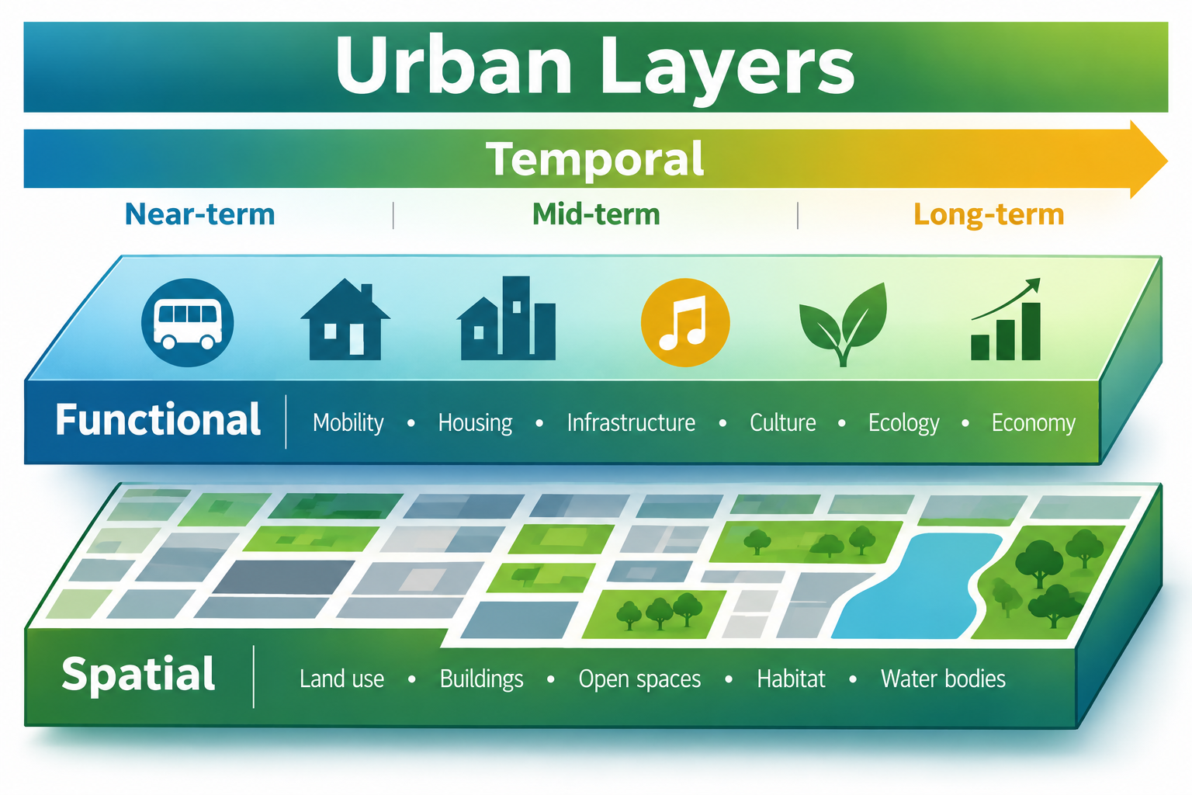
Figure 1. Urban Layers - Spatial, Functional, and Temporal dimensions.
Credit: Graphic created with AI assistance (ChatGPT, open AI)

Adaptive Scenario Planning
Adaptive Scenario Planning is a decision-making approach that embeds scenario planning — a structured way to explore and analyze multiple plausible futures to inform current decisions²⁵ — with monitoring and triggers that guide adaptive actions as conditions shift and disruptions occur^{15,18}. It can be understood as three connected streams:
- Scenario building: exploring multiple plausible futures (not predictions).
- Adaptive decision making: choosing robust actions and decision pathways (what to do now, what to do later, and under what conditions).
- Community and stakeholder participation: engaging stakeholders to develop scenarios, decisions, and strategies that are informed by community insight and that build legitimacy, resilience, and implementability while reducing the risk of conflict.
This framing reflects the convergence of established scenario planning practice, adaptive planning and Robust Decision Making (RDM) approaches under uncertainty^{20,21}, and participatory planning^{22,28}.
The graphic below depicts the three streams with their respective methods and tools^{14,16}. It is offered as a compact reference map rather than a catalogue: the methods most central to LayScen, which are morphological analysis, trends impact analysis, cross-impact analysis, Delphi input, RDM, adaptive pathways, and monitoring triggers, reappear in the workflow phases described under Section “Workflow and Methodology”
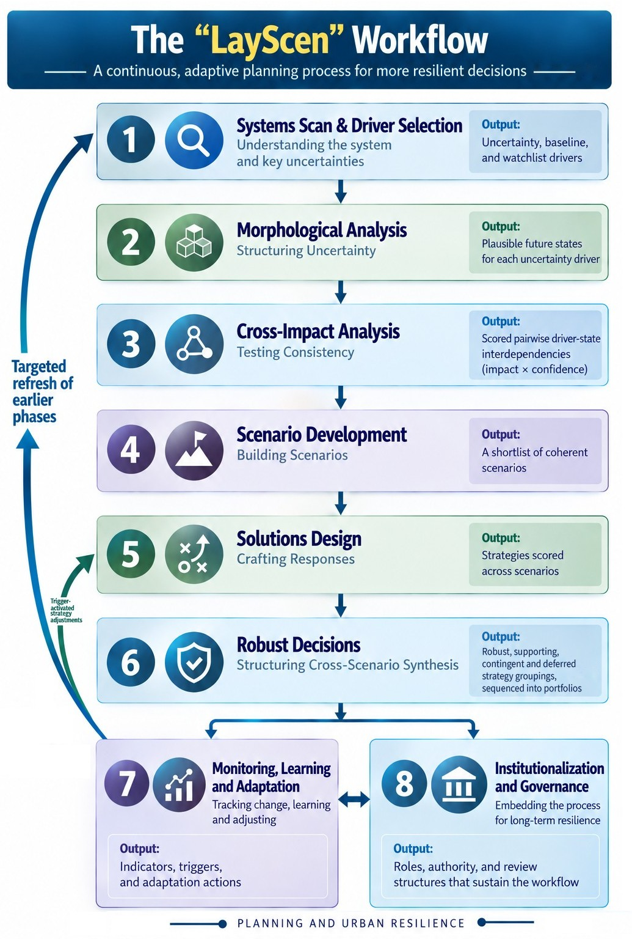
Figure 2. Adaptive Scenario Planning streams, methods, and tools.
Credit: Graphic created with AI assistance (Claude, Anthropic)

What Distinguishes LayScen
The LayScen framework integrates layered planning—across spatial, functional, and temporal dimensions—with adaptive scenario planning into a continuous decision system. LayScen does not propose entirely new scenario-planning methods or adaptive-planning theories. Rather, its contribution lies in integrating traditionally fragmented planning functions through a layered systems scan for structured uncertainty analysis, scenario development, solutions design incorporating applicable strategies, adaptive pathways, monitoring systems, and governance-linked implementation — into a continuous operational workflow for planning practice.
In operational terms, the framework does four things:
- Structures uncertainty: scans the spatial and functional layers of the urban system for structured uncertainty analysis that involve sorting drivers into uncertainty, baseline, and watchlist categories, and builds a set of coherent scenarios (maximum of six) from the driver-state combinations that can plausibly coexist.
- Converts scenarios into decisions: scores strategies across every scenario, places them on short-, medium-, and long-term horizons, and sorts them into core i.e. robust, contingent, supporting, and deferred actions: what to do now, what to hold ready, when to act, and what conditions would prompt action.
- Wires plans to reality: ties monitoring indicators to explicit trigger thresholds with pre-agreed responses, so signals prompt defined action and targeted recalibration rather than responding reactively with plan amendments or waiting for the next plan update.
- Makes adaptation shared: aligns drivers, indicators, and triggers across spatial, functional, and temporal layers, and across plans, which currently run on parallel tracks. Implementation and adaptation are sustained by governance roles and routines.

Value Propositions
Together, these functions yield three connected value propositions:
- Coordination — dynamic, integrated planning. A change in conditions prompts aligned adjustments across the spatial, functional, and temporal layers, so plans adjust in concert rather than in isolation.
- Actionability — from scenarios to decisions. Scenarios are explicitly linked to decision triggers and adaptive pathways, enabling planned and timely action rather than reactive management and modifications.
- Legitimacy and learning. The framework allows for professional, community, and expert (Delphi) input for transparent, defensible adjustments that build trust in decisions and refinements.
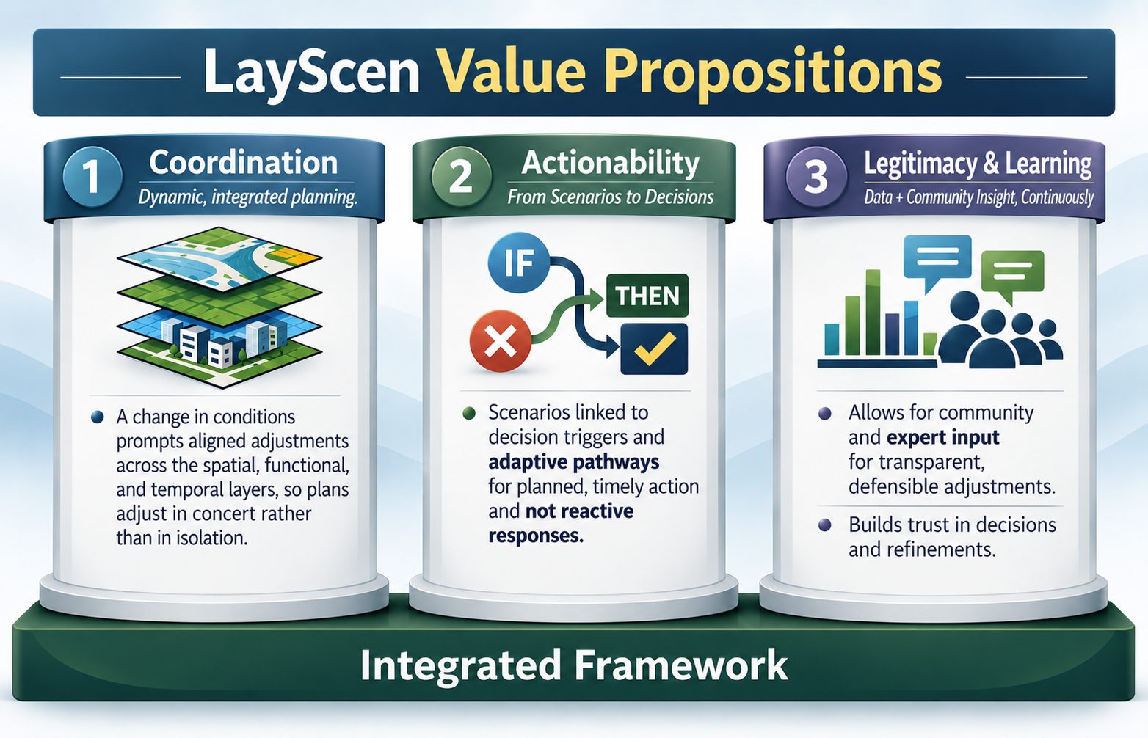
Figure 3. LayScen Value Propositions — Coordination, Actionability, Legitimacy and Learning
Credit: Graphic created with AI assistance (ChatGPT, Open AI)

Workflow and Methodology
LayScen proposes a continuous adaptive workflow that integrates systems understanding, uncertainty analysis, scenario development, strategy design, monitoring, and governance-linked adaptation. The workflow comprises eight interconnected phases, namely:
- Systems Scan and Driver Selection (output: uncertainty, baseline, and watchlist drivers)
- Morphological Analysis — Structuring Uncertainty (output: plausible future states for each uncertainty driver)
- Cross-Impact Analysis — Testing Consistency with scored pairwise driver-state interdependencies (impact × confidence))
- Scenario Development — Building Scenarios (output: a shortlist of coherent scenarios)
- Solutions Design — Crafting Responses to Impacts (output: strategies scored across scenarios)
- Robust Decisions — Structuring Cross-Scenario Synthesis (output: core, contingent, supporting, and deferred strategy groupings, assembled into sequenced portfolios)
- Monitoring, Learning, and Adaptation (output: indicators, triggers, and adaptation actions)
- Institutionalization and Governance (output: roles, authority, and review structures that sustain the workflow)
Each phase builds on the previous one, while monitoring continuously informs adjustments upstream, allowing plans to adapt as conditions change. The following figure depicts the workflow.
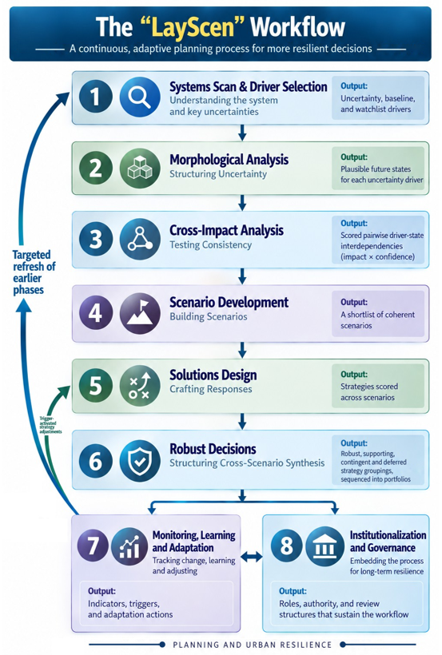
Figure 4. The LayScen Workflow.
Credit: Graphic created with AI assistance (ChatGPT, Open AI)

Phase 1: Systems Scan and Driver Selection
A structured scan identifies key components and drivers shaping change across the urban system. Drivers are identified across spatial and functional layers of the urban system simultaneously and evaluated based on influence on outcomes and uncertainty in future trajectory, using a combination of professional judgment and community input. The assessment yields three categories:
- Uncertainty drivers: These are high-influence, high-uncertainty drivers whose future state is genuinely unknowable. They shape the possible futures and form the analytical core of subsequent phases; early, proactive attention to these drivers is critical for robust urban systems.
- Baseline drivers: These are high-influence drivers that are relatively stable. These drivers establish the structural conditions that shape every future and become the “shared backdrop” common to all scenarios.
- Watchlist drivers: These are drivers with lower immediate influence and unresolved uncertainty, or slow movement until a threshold breaks. They are monitored for signals that could promote them to uncertainty drivers in future cycles; reacting early to these signals often forms the basis of proactive responses to higher-impact drivers.
Together, these categories capture not only what is uncertain, but also what is stable and what may emerge, providing a more complete representation of the system dynamics.

Phase 2: Morphological Analysis — Structuring Uncertainty
Uncertainty drivers identified in Phase 1 (a maximum of six) are carried forward for structured analysis^{14,24}. Each driver is defined by a small set (maximum of three) of plausible future states representing how conditions may evolve. This phase enables systematic exploration of uncertainty rather than speculative interpretation. The analysis includes a trends impact analysis¹⁴ that projects each driver’s current trend to the plan horizon and considers the shocks that could break it. This grounds the scenarios in observed conditions without ruling out trend-breaking futures, and gives Phase 7 (Monitoring, Learning, and Adaptation) a reference point for reading change.

Phase 3: Cross-Impact Analysis — Testing Consistency
Driver states are combined using cross-impact logic²⁷ to identify and assess interdependencies (reinforcing or conflicting). Combinations that are internally consistent and that can serve as the basis for scenario construction are selected, with optional expert (Delphi) panel input¹⁰. This phase screens out incompatible configurations and produces sets of coherent, plausible combinations (events) representing how forces are likely to interact in practice. AI-assisted methods may be used to propose the impact assessments for review.

Phase 4: Scenario Development — Building Scenarios
Consistent driver-state combinations (events) are translated and shortlisted into a manageable set of scenarios (maximum of six) using system-based tools and structured scoring. Candidate scenarios that meet a minimum level of coherence are scored based on four criteria and then curated (maximum of six) to be carried forwarded to the next phases. The four criteria for developing candidate scenarios is as follows:
- Coherence (how well the scenario’s conditions hold together)
- Coverage (how well the scenario is supported by the cross-impact assessments)
- Distinctiveness (how sharply the scenario is drawn, rather than sitting in the middle of the range), and
- Balance (the scenario’s mix of favorable and adverse conditions).
Scenarios are defined by explicit combinations of driver states accompanied by narratives, with optional AI support. Scenarios and their narratives carry forward from one planning cycle to the next, so that change can be tracked over time.

Phase 5: Solutions Design — Crafting Responses (Policies and Strategies)
In a shift from an exploration to actionable decision design, this phase identifies, develops and organizes policies and strategies on short-, medium-, and long-term timelines (temporal layers) across the selected scenarios. Each strategy is assessed within each scenario using professional judgment on plausibility, desirability, and implementation challenge, together with community input on relevance. These inputs combine into a priority score for each strategy under each scenario, enabling Scenario × Strategy comparison and forming the basis for the strategy groupings in Phase 6.

Phase 6: Robust Decisions — Structuring Cross-Scenario Synthesis
This phase bridges analysis and implementation by synthesizing Phase 5 results into clear, actionable options through pattern identification^{20,21}. Strategies are grouped in four categories as shown below, in accordance with their relevance and delineation of how actions unfold i.e. what begins now, what follows, and what is held ready against defined conditions, connecting the strategy groupings to the triggers monitored in Phase 7.
- Robust strategies: work across all scenarios.
- Contingent strategies: activated under specific conditions.
- Supporting strategies: actions that are prerequisite for others.
- Deferred strategies: actions reserved for future reassessment.
The strategies are assigned a responsible party for its implementation and grouped strategies assembled into one or more portfolios, which are sequenced sets of actions: robust strategies for implementation first, with supporting strategies put in place for actions that depend on them, and contingent strategies, which are held ready until defined conditions call for them. This sequence and its decision points form an adaptive pathway¹⁵ that Phase 7 monitors and puts into operation.
Computational or AI-assisted aggregation methods may support pattern identification; human judgment controls and interprets trade-offs.

Phase 7: Monitoring, Learning, and Adaptation
This phase establishes a monitoring system that tracks key indicators and determines when and how decisions should be adjusted. Indicators are defined to track uncertainty, baseline, and watchlist drivers so the system tracks not only change but also the validity of underlying assumptions (baseline drivers) and emerging shifts (watchlist drivers).
Triggers for each indicator specify threshold conditions and corresponding actions^{18,19}, which may include continuing along the current pathway, activating contingent strategies, switching to an alternative strategy when one in use approaches its tipping point (the threshold beyond which it no longer performs adequately), or initiating a targeted refresh of earlier phases. The monitoring functions enable targeted adjustments without restarting the process. Feedback loops update drivers, scenarios, and strategies in response to changing conditions, for example when a baseline assumption breaks, a new driver emerges, or the scenario set no longer spans observed conditions.

Phase 8: Institutionalization and Governance
Concurrently with monitoring, this phase embeds the workflow within governance structures to ensure sustained and consistent application. It defines roles, decision authority, review schedules, resource allocation, and accountability mechanisms necessary to support adaptive planning as an ongoing, disciplined, and transparent institutional practice. The workflow would run in planning cycles, on a regular review cadence and whenever events warrant.

Illustrative Operational Walkthrough
The following walkthrough illustrates one instance of how LayScen may function operationally in a real planning context. It draws on the published final documents of two San Francisco plans: the Climate Action Plan (CAP, 2026 update)⁵ and the Hazards and Climate Resilience Plan (HCR, 2025)⁶.
Context. The two plans recognize—and in several instances analyze—important interactions between decarbonization, development, infrastructure, and hazard resilience. The HCR, for example, links electrification to power-system resilience and considers development in flood- and liquefaction-exposed areas. What neither plan appears to provide, however, is a shared analytical framework that jointly varies mitigation outcomes and hazard conditions across multiple plausible futures, tests strategies across those futures, and links indicators in one domain to predefined actions in the other. This is the substrate on which the walkthrough operates.
The walkthrough is illustrative, based on the author’s reading of the public documents; it was not undertaken with the City and County of San Francisco.

Phase 1 — Systems Scan and Driver Selection
A systems scan across both plans identifies and categorizes drivers. Drivers were classified by influence on outcomes and uncertainty of trajectory. Those with high influence and genuinely open trajectories form the uncertainty set; those with high influence but stable trajectories become baseline conditions shared by all scenarios; those with lower present influence, unresolved status, or threshold-bound behavior are placed on the watchlist for monitoring and possible promotion.
Drivers are named generically, with the plan-specific instance in parentheses, so the same driver set can serve as a reusable reference core for future systems scans:

Uncertainty drivers (six selected):
- Building decarbonization (CAP: building electrification)
- Mobility transition (CAP: vehicle miles traveled and zero-emission vehicle adoption)
- Housing delivery and land use change (CAP: planned unit growth and siting)
- Coastal and stormwater flood risk (HCR: sea level rise and flooding)
- Extreme heat exposure (HCR: heat day frequency)
- Social vulnerability (HCR: concentration of vulnerable populations).

Baseline drivers:
- Existing built form and infrastructure
- The plans’ governance and accountability structures
- Fiscal capacity anchored in the City’s 10-Year Capital Plan.

Watchlist drivers:
- Transit funding stability (the CAP identifies as its leading transportation risk)
- Grid control, including potential public power acquisition;
- Wildfire smoke
- Long-term water supply reliability.

Phase 2 — Morphological Analysis
Each uncertainty driver is translated into plausible future states:
Building decarbonization — slow / on target (all buildings zero emission by 2040) / rapid.
Mobility transition — stalled / on target (vehicle miles traveled down 25 percent and 25 percent zero-emission vehicles by 2030) / accelerated.
Housing delivery and land use change — stalled / partial / met (82,000 units planned by 2030).
Coastal and stormwater flood risk — low / intermediate / high.
Extreme heat exposure — Intermittent/ frequent / chronic.
Social vulnerability — decreasing / stable / increasing.
Morphological Analysis
Driver | State 1 | State 2 | State 3
Building decarbonization pace | Slow | On target (zero-emission stock by 2040) | Rapid
Mobility transition | Stalled | On target (VMT down 25%; 25% ZEV by 2030) | Accelerated
Housing delivery and land use change | Stalled | Partial | Met (82,000 units planned by 2030)
Coastal and stormwater flood risk | Low | Intermediate | High
Extreme heat exposure | Intermittent | Frequent | Chronic
Social vulnerability | Decreasing | Stable | Increasing
Figure 5. Driver State Matrix

Phase 3 — Cross-Impact Analysis
Cross-impact analysis works pairwise rather than on whole futures. A set of six uncertainty drivers with three states each defines 729 possible complete configurations, a space too large to evaluate directly. The analysis therefore proceeds in two movements. First, each driver is paired with every other, producing 15 driver pairs and, at three states each, 135 driver-state pair combinations. Second, the pair scores are recombined to judge whole configurations.
Driver-state combinations are assessed directly. Each combination is scored on a five-point impact scale running from strongly adverse through neutral to strongly supportive, together with a confidence rating. Scores are AI-proposed and reviewed, with strong scores in either direction and low-confidence rows flagged for closer attention, and optional expert (Delphi) input where judgments are contested. Approved combinations carry forward to Phase 4, where the coherence of each candidate scenario is derived from the average of its constituent pair scores, and configurations falling below the coherence threshold are excluded. Figure 6 shows an extract of these assessments.
At full resolution, six drivers with three states each imply 135 driver-state pair combinations: 15 driver pairs, each with nine state pairings. The screening matrix manages this scale by concentrating attention: pairs screened as strong receive full state-level assessment, with potentially expert or Delphi input where judgments may be contested, while limited pairs carry default neutral ratings. The portable application under development is intended to support the full enumeration and consistency scoring.
Cross Impact Analysis
Driver A: state | Driver B: state | Impact | Confidence | Observation
Building decarbonization: rapid | Extreme heat: chronic | Neutral | Medium | Independent in cause; together place an electrified building stock at peak cooling load on an outage-prone grid
Housing delivery: met | Flood risk: high | Neutral | Medium | Independent in cause; delivery targets achieved while exposure grows, absent hazard-screened siting
Building decarbonization: rapid | Mobility transition: accelerated | Adverse | Medium | Compete for the same capital and delivery capacity in the same period
Housing delivery: stalled | Social vulnerability: decreasing | Adverse | High | Stalled delivery makes reduced vulnerability less likely
Extreme heat: chronic | Social vulnerability: increasing | Supportive | Medium | Sustained heat burden compounds health and economic stress on vulnerable populations
Figure 6. Cross-Impact Analysis: illustrative driver-state pair assessments (extract from 135 combinations).
The assessment surfaces interactions that neither plan currently examines. A rapidly electrified building stock and chronic heat are causally independent, so the combination is entirely plausible and scores neutral, yet together they place peak cooling load on a grid the HCR profiles as outage-prone under heat and seismic stress, and neither plan tests that condition. Housing delivery at target and high flood risk are likewise independent and plausible, but the HCR's observation that a westward shift lowers exposure has never been tested against the housing pipeline. Other pairs carry genuine interdependence: rapid building decarbonization and accelerated mobility transition compete for the same capital and delivery capacity within the same period, which lowers the plausibility of both occurring at full pace.

Phase 4 — Scenario Development
Three coherent scenarios emerge from the retained combinations. Coherence is determined through consistency scoring: retained combinations are those that clear the coherence threshold, similar combinations are clustered into families, and a shortlist is selected from the strongest candidates in each family to span the plausible range (favorable, mixed, and stressed futures), guided by planning team priority ratings and optional expert input. Three scenarios emerge:
- Coordinated Transition: CAP targets broadly on track, hazard conditions moderate, social vulnerability stable.
- Fragmented Adaptation: partial delivery on electrification and housing, intermediate flooding, frequent heat, increasing social vulnerability.
- Decarbonized but Fragile: CAP targets met while hazard exposures grow, with high flood conditions and chronic heat stressing an electrified city.

The third scenario is the one newly revealed through this analysis. It is coherent and plausible, yet it cannot be represented in either plan because neither plan explores how progress on climate goals, and changing hazard risks might interact across different futures.
Scenario Development/Driver | Coordinated Transition | Fragmented Adaptation | Decarbonized but Fragile
Building decarbonization pace | On target | Slow | On target
Mobility transition | On target | Stalled | On target
Housing delivery and land use change | Met | Partial | Met
Coastal and stormwater flood risk | Low | Intermediate | High
Extreme heat exposure | Frequent | Frequent | Chronic
Social vulnerability | Stable | Increasing | Stable
Figure 7. Illustrative Scenario Matrix.

Phase 5 — Solutions Design
Strategies drawn from both plans are evaluated across the scenarios, including:
- Backup power and microgrid requirements (HCR energy resilience actions)
- Building electrification support programs (CAP building actions)
- Hazard screened housing siting
- Coastal and stormwater adaptation investment
- Targeted heat protections for vulnerable neighborhoods
Each strategy is assessed for plausibility, desirability, implementation challenge, and community relevance, producing priority scores for Scenario × Strategy comparison. Strategies are also placed on short-, medium-, and long-term timelines, the temporal layer from Phase 5 of the workflow: backup power requirements and targeted heat protections sit in the near term, electrification support and hazard screened housing siting over the medium term, and major coastal and stormwater adaptation investment over the long term.

These inputs combine into a priority score for each strategy under each scenario. The result is a Scenario × Strategy matrix in which every strategy carries a score in every scenario, read in two directions. Read down a column, the matrix shows which strategies matter most if a particular future materializes. Read across a row, it shows how a single strategy performs as conditions vary, which is the more consequential view: a strategy scoring consistently across the row behaves differently in planning terms from one that scores well only under particular conditions, even where their averages are identical. This distinction in performance across scenarios, rather than the average score itself, forms the basis for the strategy groupings in Phase 6.
Solutions Design
Strategy (illustrative priority) | Coordinated Transition | Fragmented Adaptation | Decarbonized but Fragile
Backup power and microgrid requirements | Medium | High | High
Building electrification support programs | High | Medium | High
Hazard screened housing siting | Medium | High | Medium
Coastal and stormwater adaptation investment | Low | High | High
Targeted heat protections for vulnerable neighborhoods | Medium | High | High
Figure 8. Scenario × Strategy Assessment Matrix.

Phase 6 — Robust Decisions
The groupings emerge from the Phase 5 priority scores. A strategy that scores well in every scenario is at the core and named robust; one that scores well only under specific conditions becomes contingent; one that other actions depend on is supporting; and one whose case remains weak or unresolved is deferred. The temporal dimension carries over from Phase 5, where strategies are set on short-, medium-, and long-term timelines: robust strategies carry through and are applicable in all scenarios, contingent strategies are staged against their triggers as conditions evolve, supporting strategies are sequenced ahead of the actions that depend on them, and deferred items are assigned to defined future review points. Across the three scenarios, Phase 6 yields strategies as follows:
- Robust: backup power for critical facilities and heat protections for vulnerable populations perform well in all three scenarios.
- Contingent: accelerated backup power mandates activate if signals point toward the Decarbonized but Fragile scenario.
- Supporting: joining the housing pipeline data with hazard exposure mapping is a prerequisite for hazard screened housing siting.
- Deferred: major coastal capital commitments await updated sea level rise guidance, since grid investment and adaptation capital draw on the same fiscal capacity.
Portfolios are assembled from these groupings and sequenced as an adaptive pathway: backup power for critical facilities and heat protections for vulnerable populations begin now, because they perform well in every scenario. Joining the housing pipeline data with hazard exposure mapping also begins now as groundwork, since hazard screened housing siting, planned for the medium term, cannot proceed without it. Accelerated backup power mandates are prepared but held in reserve, to be activated only if the heat and electrification signals monitored in Phase 7 point toward the Decarbonized but Fragile scenario.

Phase 7 — Monitoring, Learning, and Adaptation
Monitoring builds on existing and planned mechanisms: the CAP’s planned public dashboard, the HCR 2027 mid-cycle progress report, the annual planning team review, and the 10-Year Capital Plan cycle. LayScen introduces the shared triggers these mechanisms lack. For example, heat day frequency or flood recurrence crossing HCR thresholds would re-time CAP actions such as backup power requirements, and electrification uptake rates would re-time HCR grid outage planning. A signal in one domain prompts a defined response in the other.

Phase 8 — Institutionalization and Governance
Based on the CAP and HCR documents the intent is to coordinate the two documents. The HCR commits to integrating with future CAP updates and assigns cross-plan coordination to the ClimateSF program. Phase 8 would convert that cadence alignment into shared decision rules, with defined roles, decision authority, and review schedules through which the Phase 7 triggers lead to action.

Systemwide Approach
Although only two plans are involved, the walkthrough treats them as parts of one urban system. Its six uncertainty drivers span buildings and energy, mobility, housing and land use, climate hazards, and community and society, and they are analyzed as a single shared set rather than plan by plan.
The analysis also works across all three layers. Functionally, cross-impact analysis finds interactions that fall between the plans, such as an electrified building stock meeting chronic heat on the same grid. Spatially, strategies land on specific places: hazard-exposed housing sites, critical facilities, and heat-vulnerable neighborhoods. Temporally, near-, medium-, and long-term actions are sequenced into one pathway. Shared constraints are weighed together, as when grid investment and coastal adaptation draw on the same fiscal capacity, and a signal in one domain prompts a response in the other through shared decision rules.
In summary, the illustrative walkthrough shows one instance of LayScen operating on real world plans, where its contribution lies in the connective analysis neither of the two considered plans contains. A scenario set/plausible futures spanning both domains, cross-impact analysis, and trigger pathways let two well-run plans adjust in concert.
The same structure could take in further plans, such as a general plan, capital plan, or transportation plan, by adding their drivers and strategies to the shared set rather than creating another parallel track.

Implementation Considerations and Workflow Support
LayScen is intended to be supported by an evolving portable application to assist practitioners in operationalizing the workflow within planning and decision-making contexts. This application remains under development; its refinement will be guided by user input and feedback from pilot applications.
The framework and its workflow, however, do not depend on a fully developed software application. Their primary contribution lies in the planning architecture and operational logic that integrate layering/layered systems scan for structured uncertainty analysis, scenario development, solutions design, robust decision making, monitoring and triggers, and governance into one continuous workflow for planning under uncertainty and rapid change.
The relationship among framework, workflow, and application can be stated simply: the framework is the idea, the workflow is the method, and the application is the tool. The framework joins layering and layered systems thinking with adaptive scenario planning. The eight-phase workflow turns that framework into a repeatable, step-by-step operating procedure a planning team can run. The portable application will carry the workflow into day-to-day practice, supporting data management, analysis, and monitoring through implementation.

Potential Applications
The framework is envisioned as particularly applicable in planning environments characterized by long implementation horizons, interconnected systems, and rapidly evolving uncertainty conditions.

Limitations
LayScen is presented as a conceptual and operational framework proposal rather than a validated empirical methodology. Its effectiveness will depend on context-specific implementation capacity, institutional coordination, stakeholder participation, and data quality. The framework may require substantial organizational coordination in resource-constrained environments, and AI-assisted components require appropriate governance, transparency, and human oversight.

Future Development and Research
LayScen is being advanced in stages. Framework and workflow formulation is documented in this paper. It is offered for exploration and evaluation for implementation in real world contexts.
Current work centers on development of a supporting portable application to enable implementation. The application will be refined through user input and feedback from pilot projects. Real world implementation and evaluation is anticipated thereafter.
The author welcomes collaboration with practitioners, agencies, and research partners interested in piloting and evaluating the workflow and would especially value input on the utility of the workflow, challenges to implementation, and suggestions for refinement that would facilitate implementation, i.e.: Would it be useful in practice? Where could it face real-world obstacles? What would make it more workable?

Conclusion
Urban planning increasingly operates under rapidly changing and uncertain conditions. Factors such as climate volatility, infrastructure stress, economic instability, governance complexity, and technological disruption challenge plans built around assumptions of relatively stable long-range conditions. Even adaptive planning, though an advancement, has in practice often remained fragmented, weakening system-wide resilience.
LayScen - Layered Adaptive Scenario Planning, is proposed as an integrated planning framework that supports coordinated, system-wide, adaptive responses to meet the challenges of compounding uncertainty in conditions that affect planning to enable urban Resilience.
This framework and workflow are offered to the planning and related professional community for exploration and evaluation. The supporting portable application now under development will be tested and refined through pilot projects and user feedback on the path to real world implementation, with the goal of enabling resilience for our cities and communities.

Acknowledgement
The author used ChatGPT (OpenAI) and Claude (Anthropic) as assistive tools for literature search, organization and synthesis, drafting and editorial support, and portions of the analysis — reviewed, refined, and validated by the author. Integration, interpretations, and conclusions are the author’s own.

References and Supporting Literature
- Batty, M. (2013). The New Science of Cities. MIT Press.
- California High-Speed Rail Authority. (2008). California High-Speed Train Business Plan. Sacramento, CA: California High-Speed Rail Authority.
- CalMatters, “Newsom will inherit troubled bullet train project”, December 3, 2018; “Newsom is shrinking Brown’s pet projects”, May 8, 2019; “California bullet train project still lacks needed financing” March 22, 2023 (last accessed April 14, 2026).
- California High-Speed Rail Authority. Project Overview. https://hsr.ca.gov/about/project-overview/ (last accessed August 13, 2026).
- City and County of San Francisco. (2026). San Francisco Climate Action Plan (2026 Update, Final May 2026). https://sfclimateplan.org/ (last accessed August 13, 2026).
- City and County of San Francisco. (2025). San Francisco Hazards and Climate Resilience Plan (FEMA approved August 2025). Office of Resilience and Capital Planning.
- City of Minneapolis. Minneapolis 2040 — The City’s Comprehensive Plan. https://minneapolis2040.com/ (last accessed April 14, 2026).
- City of Phoenix. (2025). PLANPHX 2025 Update Executive Summary.
- City of Phoenix. "City of Phoenix Unveils Robust 2026 Heat Response Plan", February 26, 2026; "Phoenix City Council Receives Update on Water Resources, Drought Preparedness and Long-Term Water Security", April 28, 2026; "City of Phoenix Creates or Preserves 50,000 Housing Units 5 Years Ahead of Goal", February 5, 2025; Housing Phoenix Plan; 2026–31 Preliminary Capital Improvement Program; "City of Phoenix Updates Zoning to Safeguard Health and Safety as Data Center Growth Accelerates", July 2, 2025 (Zoning Ordinance Text Amendment Z-TA-2-25) (last accessed August 15, 2026).
- Dalkey, N., & Helmer, O. (1963). An Experimental Application of the Delphi Method to the Use of Experts. Management Science, 9(3), 458–467.
- Federal Reserve Bank of Minneapolis. (2024, April 11). Minneapolis 2040 Plan data tool prepared to measure impacts. https://www.minneapolisfed.org/article/2024/minneapolis-2040-plan-data-tool-prepared-to-measure-impacts (last accessed April 14, 2026).
- Federal Reserve Bank of Minneapolis. (2025, August 25). Unpacking supply and demand in rent trends since the Minneapolis 2040 Plan. https://www.minneapolisfed.org/article/2025/unpacking-supply-and-demand-in-rent-trends-since-the-minneapolis-2040-plan (last accessed April 14, 2026).
- Folke, C., et al. (2010). Resilience Thinking: Integrating Resilience, Adaptability and Transformability. Ecology and Society, 15(4).
- Glenn, J. C., & Gordon, T. J. (2009). Futures Research Methodology. Millennium Project.
- Haasnoot, M., Kwakkel, J. H., Walker, W. E., & ter Maat, J. (2013). Dynamic Adaptive Policy Pathways: A Method for Crafting Robust Decisions for a Deeply Uncertain World. Global Environmental Change, 23(2), 485–498.
- Holmberg, J., & Robèrt, K.-H. (2000). Backcasting — A Framework for Strategic Planning. International Journal of Sustainable Development & World Ecology, 7(4), 291–308.
- Kato, S., & Ahern, J. (2008). “Learning by Doing”: Adaptive Planning as a Strategy to Address Uncertainty. Journal of Environmental Planning and Management, 51(4), 543–559.
- Kwadijk, J. C. J., et al. (2010). Using Adaptation Tipping Points to Prepare for Climate Change and Sea Level Rise. WIREs Climate Change, 1(5), 729–740.
- Lawrence, J., & Haasnoot, M. (2017). What It Took to Catalyse Uptake of Dynamic Adaptive Pathways Planning. Environmental Science & Policy, 68, 47–57.
- Lempert, R. J., Popper, S. W., & Bankes, S. C. (2003). Shaping the Next One Hundred Years: New Methods for Quantitative, Long-Term Policy Analysis. RAND Corporation.
- Marchau, V. A. W. J., Walker, W. E., Bloemen, P. J. T. M., & Popper, S. W. (2019). Decision Making under Deep Uncertainty: From Theory to Practice. Springer.
- Nadin, V., Stead, D., et al. (2021). Integrated, Adaptive and Participatory Spatial Planning: Trends across Europe. Regional Studies, 55(5), 791–803.
- Rangwala, T. (2024). Literature Review: Adaptive Planning Practices. Water, 16(12), 1657.
- Ritchey, T. (2002). General Morphological Analysis: A General Method for Non-Quantified Modelling. Swedish Morphological Society.
- Schoemaker, P. J. H. (2022). Advanced Introduction to Scenario Planning. Edward Elgar.
- Walker, W. E., Haasnoot, M., & Kwakkel, J. H. (2013). Adapt or Perish: A Review of Planning Approaches for Adaptation under Deep Uncertainty. Sustainability, 5(3), 955–979.
- Weimer-Jehle, W. (2006). Cross-Impact Balances: A System-Theoretical Approach. Technological Forecasting and Social Change, 73(4), 334–361.
- Zandvoort, M., et al. (2019). Dealing with Uncertainty in Collaborative Planning. Journal of Environmental Planning and Management, 62(2), 248–265.

